Jimmy Carter National Historical Park
National Park Service
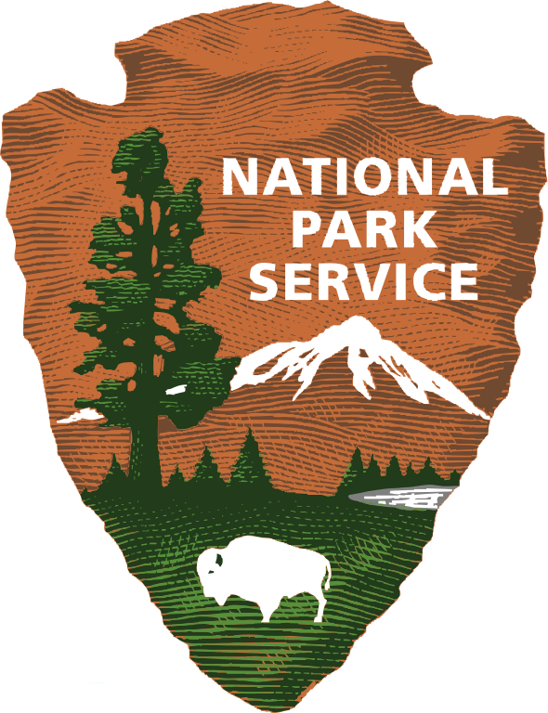

Jimmy Carter National Historical Park Field Trip Reservations

On-site field trips are offered with standards-based, grade specific, activities.
Reservations are required for guided educational programming.

Jimmy Carter Boyhood Farm
Recommended for Pre-K -12 grade
Students participate in hands-on, cross-curricular activities as they learn about President Carter’s childhood, the influential people in his life, and farm life in the 1930’s.

Time requirement
A full farm tour with activities and a scheduled picnic lunch break will require a commitment of at least 3 hours. Shorter visits can be accommodated however, some activities will not be included due to time constraints.

Plains High School Museum
Recommended for 2nd-12th Grade

Students participate in interactive lessons and activities as they learn about his life as a child of the great depression, his accomplishments as president, and his journey to becoming a world-renowned humanitarian and champion for civil rights and peace!

Time requirement:
A full Plains High School tour will require a commitment of at least 2 hours depending on the group size. A visit to PHS can be planned in conjunction with a visit to the
Boyhood Farm upon request.

Christmas on the Farm
Recommended for grades 1st-5th
Available late November-December
Students travel back in time to experience Christmas traditions that would have been celebrated by Jimmy Carter and his family in the 1930’s. Students participate in the standard field trip activities with the addition of hands-on, Christmas themed activities.

Group size for all Field Trips

Max 60 students (groups will be split into groups of 20 and then scheduled in rotations).
If your group/grade level is larger than 60 students, please plan to schedule multiple days for your school.
If accommodations cannot be made to schedule multiple days, please indicate on your registration form. We do not want this to detour your school from visiting our site.

Schedule a Field Trip
Complete the attached information and email to:

Patty Kuehn
JICA_Education@nps.gov
229-942-0045

Please provide desired dates on the attached form. Field trip reservations must be confirmed by education staff. The field trip coordinating teacher will be contacted by education staff via phone or email when reservation is confirmed to discuss program details, large group requests, and specific curriculum needs. A field trip planning guide with pre and post visit instructions and activities will be provided at that time.

Additional resources and curriculum information can be found at: www.jimmycartereducation.org

Jimmy Carter National Historical Park
National Park Service

Field Trip Request Form
Please download document, complete, and email as an attachment to: JICA_Education@nps.gov

Field Trip Coordinator/Teacher:
School Name:
School System (County):
School Phone:
Field Trip Coordinator/Teacher Cell Phone:
Field Trip Coordinator/Teacher E-mail:

Requested Date 1st choice | Requested Date 2nd choice | Requested Date 3rd choice

Grade Level
Number of Students
Number of Classes
Program(s) Requested  Please circle choice | Boyhood Farm  Plains High School
Arrival Time
Departure Time
Picnic Lunch on Site | Yes | No

Participating Classroom Teachers

Name | Email | Phone

Jimmy Carter National Historical Park
Education Program
Travel Grant Application

Travel Grants are to help cover school bus transportation costs. Commercial buses and private vehicles are not eligible for funding. Applications for travel grants must be submitted with field trip reservation for consideration. This funding is made possible through the generosity of donors to the Friends of Jimmy Carter National Historical Park.

A. APPLICANT INFORMATION
NAME OF SCHOOL: | NAME OF TEACHER/CONTACT PERSON:
SCHOOL ADDRESS: | SCHOOL PHONE:
 | EMAIL OF CONTACT:
COUNTY: | SCHOOL FAX:
Field trip date:
Please specify the school name or organization (district transportation department) that the check should be written to. Checks cannot be made out to an individual.

Please specify name and address that the check should be sent to:

B. BUDGET
Category | Amount
Number of Buses
Example: 2
Bus mileage
Example:138 miles @ 2.50/ $345.00 x 2 = $690
Bus driver salary
Example: $13 per hr. @ 10 hours/ $130.00x2= $260

TOTAL COST OF TRIP
$950
C. AUTHORIZED SIGNATURE

For Official Use Only Date Received: | Approved _____ Disapproved _____
Reviewed by: Date: | Justification:

